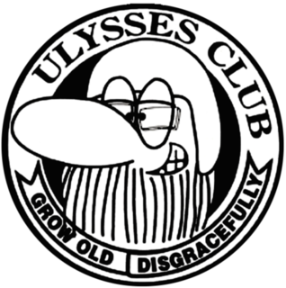
Taranaki Branch Ulysses Meeting Minutes Wednesday 19 June 2019
Venue: New Plymouth club
Meeting started 6 pm
Present: Graeme Weston # 5686, Shane Le Breton, Andrew Pentelow # 8533, Gemma Peyerl # 9484, Martin Peyerl # 9483, Suzy Pentelow # 8532, Alan Foster # 9050, Harry Bayliss # 9680, Blair Campbell # 2772.
- Apologies: Bill kidney # 7217. Moved Suzy; seconded Blair
- Minutes: Passed as true and correct. Moved Graeme; seconded Andrew
- Matters arising: The Volcano café we visited on our monthly club ride was very good and it was suggested by Shane we try it again in the future for one of our Monthly Sunday lunches. Whangamomona club overnighter was a great success and Andrew was thanked for organizing it and looking after us all. Gemma started some discussion about the rules for rides. It was decided the organizer decides who leads and Graeme suggested we could have turns being tail end Charlie and the rider in charge will also work this out. If we are changing roads it’s important to make sure the person behind knows so wait for them at the turn off. Tail end Charlie must stay at the back. Harry is to get a Taranaki secretary badge and two committee badges. It was suggested we catch up more often for events and Shane thought we could do some book a bach trips where we could all stay together.
- Financial report: Moved as correct and bills passed for payment.
- Rides: 21/7/2019 ride is to Waitotara Hotel. Lead rider is Ray. Leaving Inglewood at 10.30 am. There was more discussion on the way we run these, and Alan commented he liked how Martin does it with a detailed briefing and checking at turn off points everyone is alright. It was suggested on the way home that those who wanted to make their way home away from the group was fine so long as everyone knew.
- General business: There was a vote on the new logo and the results were: six for the logo with the yellow sunrise above the old man and the Taranaki name below. Then the other three votes were spread over three other choices. To start with we are going to have a banner made up with our new logo, and perhaps later a shirt and badges.
AGM meeting minutes to be discussed at next meeting. Next year’s AGM to be held at the New Plymouth Club.
Gemma suggested we be more proactive and have a group looking into things for us to do and places to go and bring suggestions to the rides committee. This could also involve going to non-riding events. e.g. shows. Shane is looking into ways that if something is on, we can get a quick response for everyone if they are interested.
The new date for Ride Forever will be set for some time in October.
Blair suggested setting dates for our next rally in November in 2020 with a suggestion of 20, 21 & 22 Nov or 27, 28 7 29 November. A subcommittee needs to be formed, and the earlier the better for dates to be confirmed so it can go in the Ulyssean magazine. We need to see what other Rallies are on around then. Blair also suggested when wearing our logos as a patch on jackets we could considered to be a gang.
Meeting closed at 6.52 PM
Also present: Jeff Ransley #9846, Kevin Beetham, John Newport #3503, Graham Voss # 486, Janet Voss, Scott Mills #9845, Joy Campbell #2772, Janice Weston # 9927

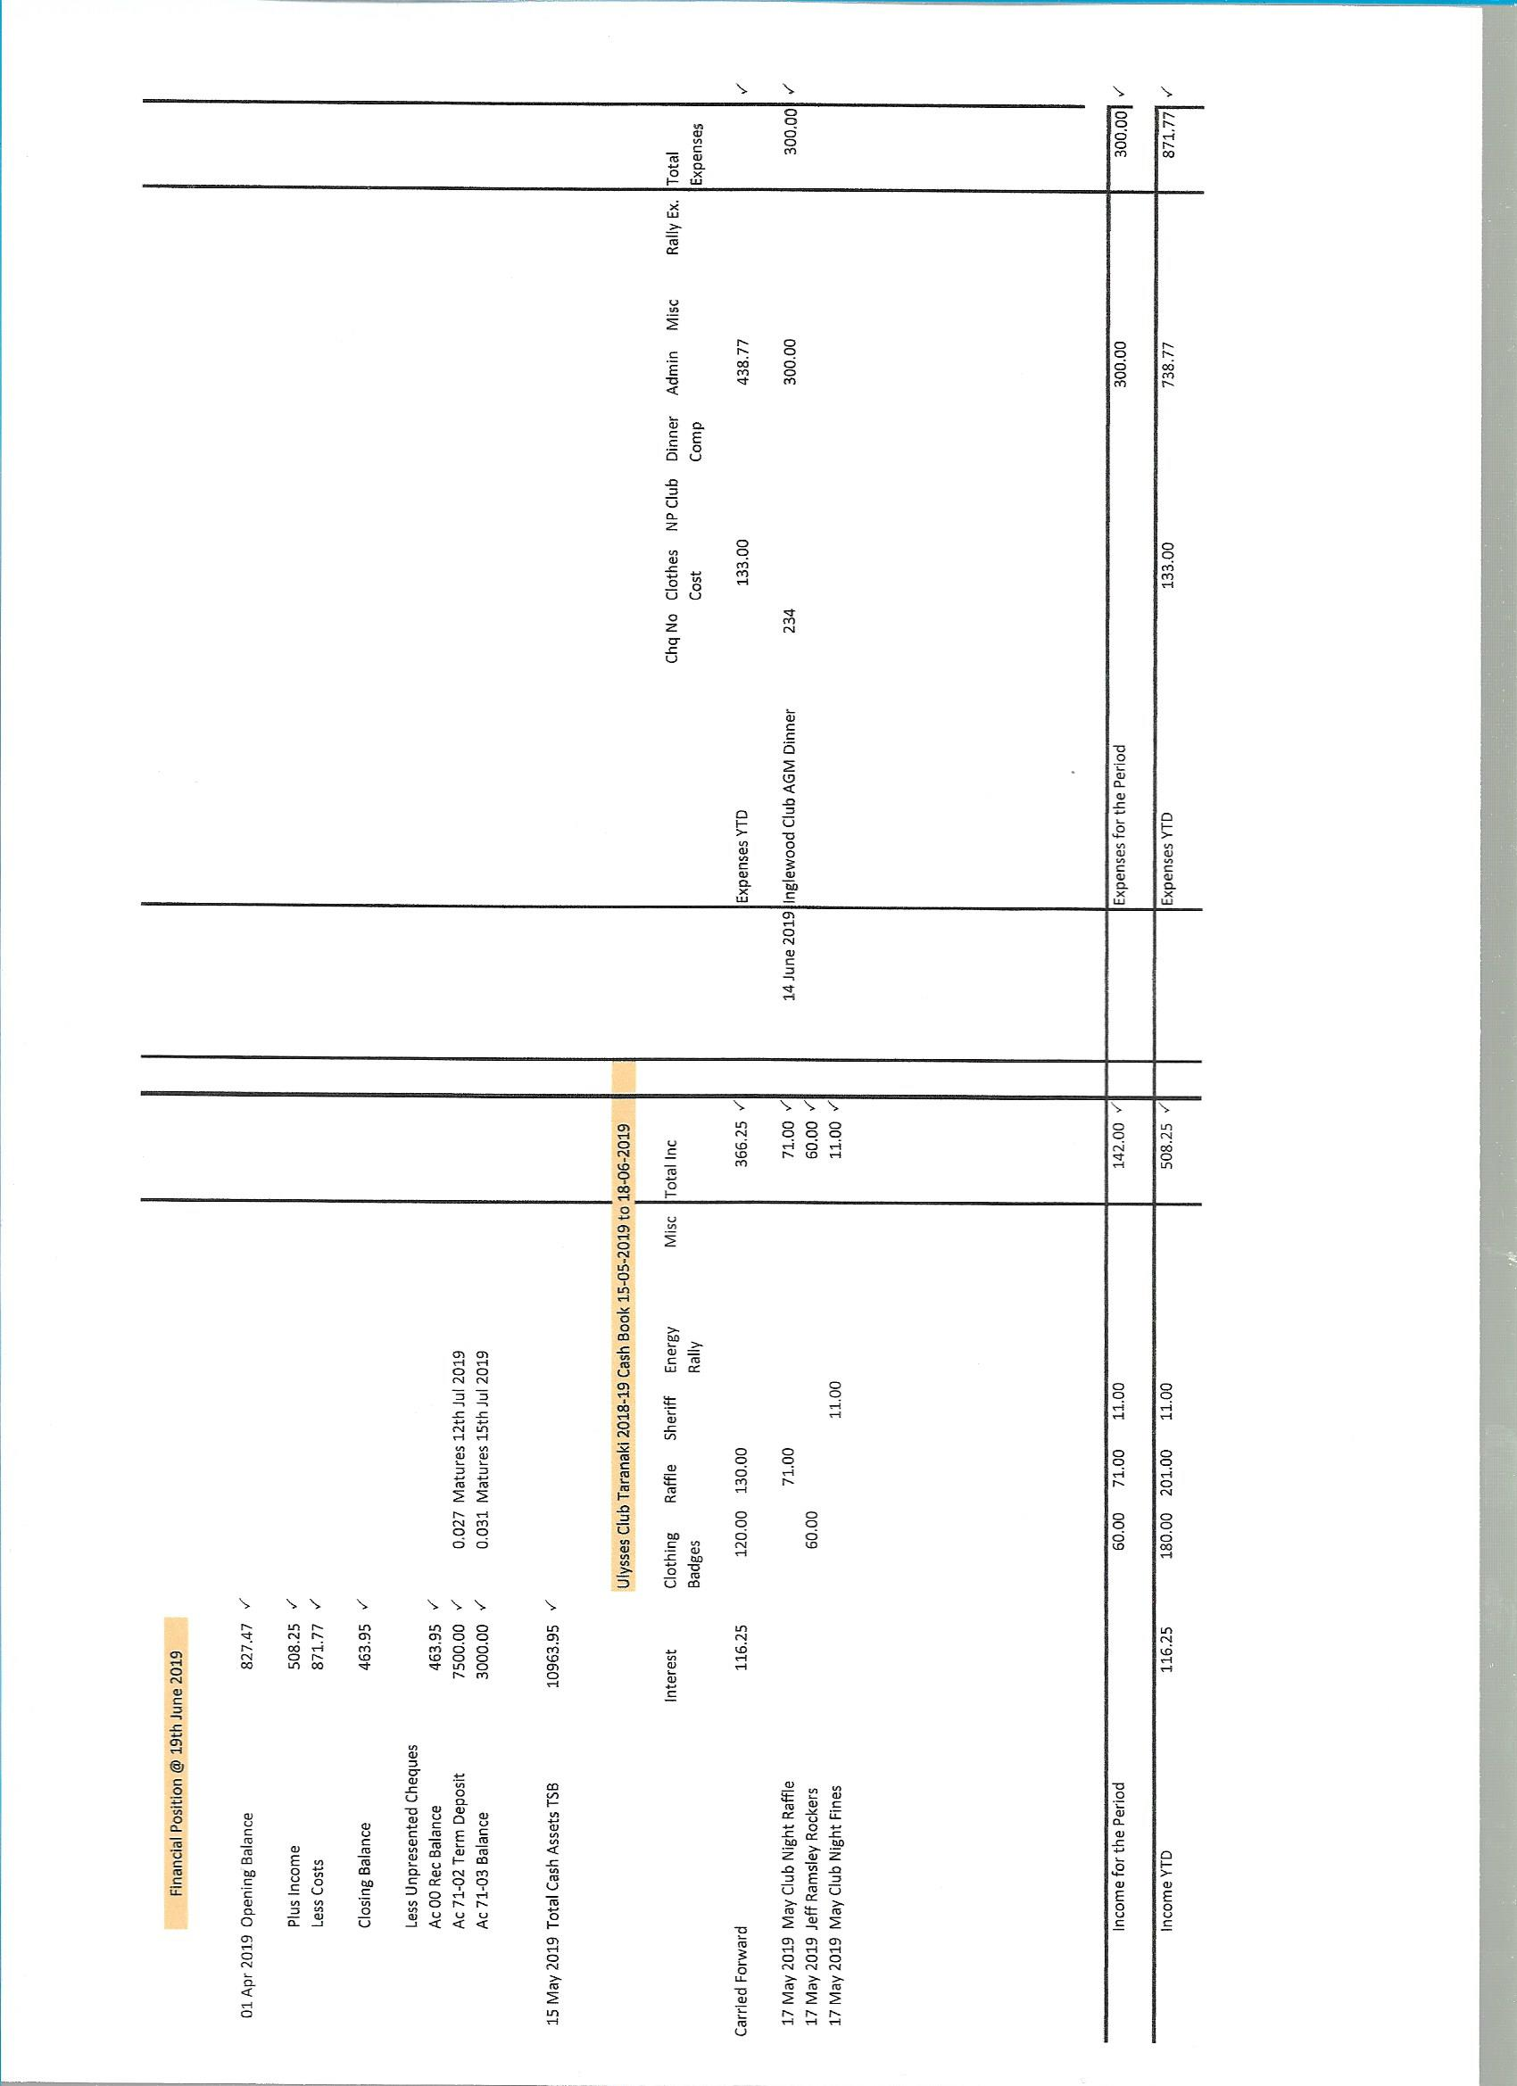gfgfh

